

SCS DTACC Messaging Group

TIBCO EMS /
Informatica v7.1.4

Integration Guide

Version | 1.0
Date | September 18, 2006
Author | SCS DTACC Messaging Group
Status | Draft

Revision History

Version | Date | Author | Description
1.0 | September 18, 2006 | Andy Bither | Original draft version of document.

Table of Contents
1 Introduction 3
2 Scope 3
3 Assumptions 3
4 EMS Configuration 4
4.1 Provide the EMS Server Instance URL 4
4.2 Create UserID 4
4.3 Create Queue and Topic Connection Factories 4
4.4 Create a Queue 5
4.5 Create a Topic 5
4.6 Create ACL 5
5 Informatica Configuration 6
5.1 Registering EMS Jar Files 6
5.2 Configuring Application Connection Properties 7
5.2.1 Connection Attributes for JNDI Application Connections 8
5.2.2 Connection Attributes for JMS Application Connections 9

Introduction
Messaging systems are the backbone of the business applications at Credit Suisse.
TIBCO EMS (Enterprise Messaging Service) is the firm’s strategic platform for high-speed asynchronous messaging because of its performance, flexibility, and reliability.
Informatica is an older legacy messaging system still used by many applications in Credit Suisse, especially in the ones that use BEA WebLogic, such as Prime Services. One of Informatica’s salient features is its ability to perform message transformation and workflow processing. As business requirements become more complex, these applications must communicate with other systems. EMS is an ideal bridge for this function because it implements the JMS 1.1 specification, which is well supported by Informatica.
The integration process consists mainly of configuration. The Informatica Workflow Manager GUI is used to create application connections that define JMS sources and targets for the PowerCenter Server and the Realtime PowerConnect JMS.
This document provides a detailed step-by-step process for integrating Informatica and TIBCO EMS.

Scope
This document provides integration specifics between the following versions:
- Informatica v7.1.4
- EMS Server 4.3.0 (though it is expected there should be no issues with prior or future versions)
This document is not intended to be an Informatica/EMS primer. Please refer to the appropriate documentation for detailed architectural understanding of these products

Assumptions
This document assumes you have a running Informatica Server and EMS Server instance.

EMS Configuration

Provide the EMS Server Instance URL
Lookup the listen parameter value in “tibemsd.conf”, the main EMS configuration file. Provide this value to the Informatica administrator. The listen parameter for the EMS server is of the form:
listen=tcp://<hostname>:<port>
The value provided to the Informatica administrator for the POC was:
tcp://nys45a-6902.corpny.csfb.com:8101

Create UserID
Use the EMS Admin shell commands to create a UserID, a Group, and to assign the UserID to the Group. Then provide the UserID and Password to the Informatica administrator.
create user <name> [<description>] [password=<password>]
create group <name> [<description>]
add member <group-name> <user-name>[,<user-name2>,...]
The following command removes users from a group.
Remove member <group-name> <user-name>[,<user-name2>,...]
This POC created the following UserID and password.
UserID: gsl
Password: gsl_dev

Create Queue and Topic Connection Factories
Use the EMS Admin shell command to create a queue and topic connection factory and then provide those names to the Informatica administrator.
create factory <name> <type> [<properties>]
Worth noting is that Informatica does not support the “generic” type of connection factory because Informatica does not support the JMS v1.1 specification. It supports only queue and topic connection factories. That is unfortunate because DTACC encourages using generic connection factories so that destinations can be changed from queues to topics without affecting the underlying application code.
This POC created the following connection factories.
create factory QueueConnectionFactory Queue url=tcp://nys45a-6902.corpny.csfb.com:8101
create factory TopicConnectionFactory Topic url=tcp://nys45a-6902.corpny.csfb.com:8101

Create a Queue
Use the EMS Admin shell command to create a queue and provide the name to the Informatica administrator.
create queue <name> [<properties>]
This POC created a failsafe queue, Q.GSL, using default settings for all of the other properties.
create queue Q.GSL failsafe

Create a Topic
Use the EMS Admin shell command to create a queue and provide the name to the Informatica administrator.
create topic <name> [<properties>]
This POC created a failsafe topic, T.GSL, using default settings for all of the other properties.
create topic T.GSL failsafe

Create ACL
Use the EMS Admin shell command to create access rights to the queue and topics created. Note this grants access of the queues and topics to a group but has nothing to do with Informatica administration. Permissions include
grant topic <topic-name> <[group=]group-name>|<[user=]user-name> <permissions>
grant queue <queue-name> <[group=]group-name>|<[user=]user-name> <permissions>
Permissions allow the application to perform such things as send, receive, browse, publish, subscribe, and so forth on the destinations. Note for this POC, no ACL was specified for the GSL queue and topic. As a result the application had full access to those destinations.
The following commands were used for this POC.
grant topic T.GSL group=gsl publish,subscribe
grant queue.Q.GSL group=gsl send,receive

Informatica Configuration

Registering EMS Jar Files
The EMS client libraries (JAR files) must be registered on the machine hosting the Informatica PowerCenter Server. This can be done by:
- Copying the libraries to the PowerCenter Server directory or
- Setting the CLASSPATH environment variable
The EMS JAR files are located in the EMS java client directory. For instance,
/app/ems/4.3.0/clients/java
Copying the JMS Provider Libraries to the PowerCenter Server Directory
On Windows, UNIX, or Linux, copy the EMS JAR files to the <PowerCenter Server>/bin/javalib directory. When the PowerCenter Server is installed, the installation program creates this directory. For instance,
c:\Program Files\Informatica\PowerCenter Server\bin\javalib
Setting the CLASSPATH in Windows
If the EMS JAR files are not in the JRE\lib\ext directory, set the CLASSPATH to the directory containing the EMS JAR files.
set CLASSPATH=/app/ems/4.3.0/clients/java;$CLASSPATH
Setting the CLASSPATH in UNIX or Linux
If the EMS JAR files are not in the JRE\lib\ext directory, set the CLASSPATH to the directory containing the EMS JAR files.
setenv CLASSPATH /app/ems/4.3.0/clients/java:$CLASSPATH
In this Integration POC, all of the EMS jar files were copied into the Informatica environment. It is likely that some of these jar files are not necessary for the Informatica integration; however, there is no harm to include all of the jar files.
crimson.jar
jaxp.jar
jms.jar
jnet.jar
jta-spec1_0_1.jar
tibjms.jar
tibjmsapps.jar
jcert.jar
jndi.jar
jsse.jar
tibcrypt.jar
tibjmsadmin.jar
tibrvjms.jar

Configuring Application Connection Properties
Before the PowerCenter Server can extract data from JMS sources or write data to JMS targets via the RealTime PowerConnect JMS, application connections must be configured for JMS sources and targets via the Workflow Manager GUI. The PowerCenter Server and the RealTime PowerConnect JMS uses two types of application connections to connect to a JMS provider during a session to read and write JMS messages.
- JNDI application connection
- JMS application connection

Connection Attributes for JNDI Application Connections
Configure a JNDI Application Connection to lookup JMS administered objects in a JNDI server.
In this particular Integration POC, the EMS server itself is the JNDI server. The PowerCenter Server and the RealTime PowerConnect JMS use the JNDI configured information to lookup the JMS administered objects in EMS.
The JNDI application connection is configured using the Connection Object Definition dialog box. Select JNDI Connection in the Type dropdown edit box.
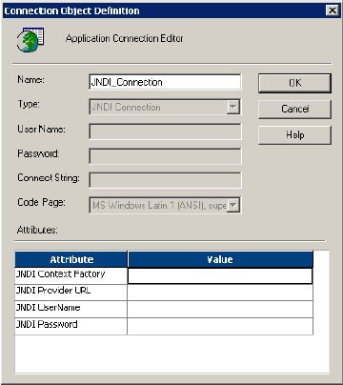

Set the attributes as follows:
Attribute Name | Attribute Value
JNDI Context Factory | com.tibco.tibjms.naming.TibjmsInitialContextFactory
JNDI Provider URL | Tibjmsnaming://nys45a-6902.corpny.csfb.com:8101
JNDI User Name | gsl
JNDI Password | gls_dev

Connection Attributes for JMS Application Connections
Configure a JMS Application Connection to connect to JMS providers during a PowerCenter session to read source messages or write target messages.
The JMS Application Connection is configured using the Connection Object Definition dialog box. Select JMS Connection in the Type dropdown edit box.
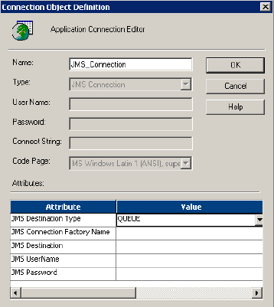
Set the attributes as follows:
Attribute Name | Attribute Value | Description
JMS Destination Type | Queue | Select QUEUE or TOPIC for the EMS Destination Type.
JMS Connection Factory Name | QueueConnectionFactory | EMS connection factory name that PowerCenter will use to create a connection with EMS.
JMS Destination | Q.GSL | EMS destination name.
JMS User Name | gsl | EMS User Id
JMS Password | gls_dev | EMS Password

